SPARK: Simple Play Adaptations to Reference for Kids

Travel Door Alarm
Description: | Image:
This door alarm has a small shape and a smart design with a high pitched 91 decibel alarm that will sound if the door begins to open. Detailed with a cord that hangs easily over any standard doorknob, alarm includes a convenient and runs on two CR2032 button-cell batteries. This travel alarm adds an extra measure of safety and security to any door. Hold the thin blades of the alarm prongs together and slide them into the crack between the door and doorframe, loop the cord around the door handle, and set the alarm. | 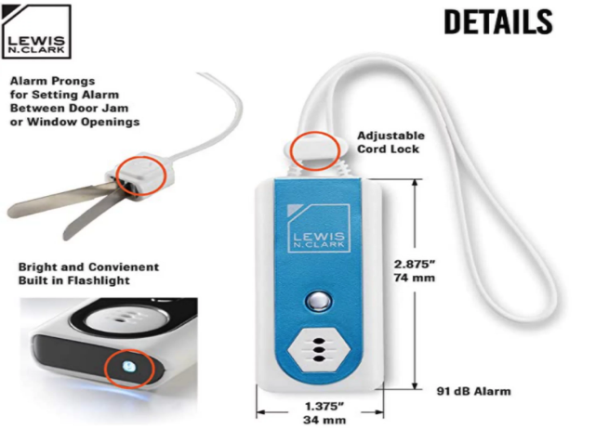  Purchasing Information  Demo Video

Who Might Benefit?
Those who…
• Are responsible for supervising children.
• Act on impulse and try to open doors and gates.
• Attempt to follow a child who opens doors or gates.

Why Use?
Provides an opportunity to…
• Acts as a safety measure for those who try to leave an area due to:
• Becoming overstimulated in the classroom
• Wandering from supervised areas
• Attention Seeking
Instructions for Use: | Adaptation Ideas:
Environmental Considerations  - Be aware of how the noise level or amount of visual stimulation or busy activities may affect certain children.  - Create boundaries such as a taped box in front of the doorway as a “no stand zone”.  - Place the desk or table where the teacher spends the most class time close to the door to allow for quick intervention.  - Place a stop sign on door or outside gate.  Positioning  - Strategically place the child away from an accessible door. If possible, have an adult positioned close to the child as well as the door to redirect them if they try to leave.  Play/Use with Others  - Create a poster about leaving the area to be reviewed daily in morning circle/meeting, as well as posted on or near the door as a reminder to children who struggle with elopement.  - Combine poster or social stories about leaving designated areas with community signs/traffic lights with concepts of stop (red light), go (green light), wait or caution (yellow light).  - Play Red Light Green Light game and discuss instances of when it is important to stop, and OK to go. | Communication Support  - Visuals displaying options of things children can say or do when they feel like they need to "get away".  - Create lanyards for all staff with visuals including stop, wait, I need a break.  - Create an individual or class Social Story (e.g. Staying With My Class, Running Away, I Can Choose to Be Safe.)  DIY Alternatives  - “Sleigh bells” or other movement triggered noisemaker on doors and gates.  - Stop signs posted on doors and gates.  - If the home has a security system, check to see whether a door alarm can be activated when the door opens and/or closes.

Resources:

See Social Narratives from OCALI’s Autism Center Grab and Go Resource Gallery of Interventions

For further information, visit the Social Narratives Autism Internet Module

Like Social Stories, Power Cards teach and reinforce academic, behavioral, organizational, and social skills. Power Cards are visual supports that include an individual’s special interest. See Power Cards from OCALI’s Autism Center Grab and Go Resource Gallery of Interventions

Reminder Cue Cards from OCALI’s Autism Center Grab and Go Resource Gallery of Interventions help teach and remind individuals how to engage in positive behaviors. Reminder Cue Cards provide “what to do” suggestions when an individual is feeling anxious, stressed, or confused. They also support interactions with peers, and offer ways to self-regulate, and manage emotions.

Ohio Early Learning Standards:

SS. People, Communities, and their Environment: Develops understanding that everyone has rights and responsibilities within a group (1.c.).
- PD&W. Wellness: Demonstrates increasing understanding of safety practices and behaviors (2.f.).

Words to Encourage Play/Use
Stop | Go | Wait
Open | Close | Help
Sad | Mad | Scared
*”Adaptations” adapted from: Haugen’s Modes for Adapting Toys based on materials from the "Let's Play" Project at the University of Buffalo
PCS is a trademark of Tobii Dynavox, LLC. All rights reserved. Used with permission.

